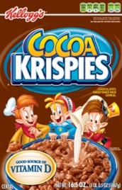

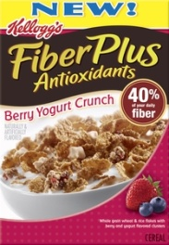**11.5 – 16.5 oz. Selected**

**Kellogg’s Cereal**

**2/$4**

**100 oz. Selected 2X**

**Liquid Gain Detergent**

**[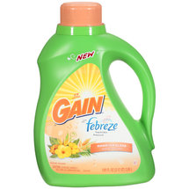](javascript:photo_opener('http://i.walmartimages.com/i/p/00/03/70/00/24/0003700024030_500X500.jpg&product_id=14272800','/catalog/detail.gsp','1','false','','-9223372036854775808');)$7.99**

**64 oz. Selected**

**Sunny D Punch**

**[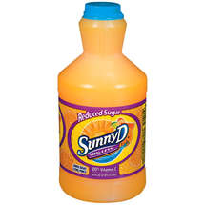](javascript:photo_opener('http://i.walmartimages.com/i/p/00/05/02/00/01/0005020001607_500X500.jpg&product_id=10805136','/catalog/detail.gsp','1','false','','-9223372036854775808');)2/$3.00**

**24 pack .5 Liter Shurfine**

**Spring Water**

**$2.99**

**1 Gallon Selected**

**Valu Time Ice Cream**

**12 pk 12 oz selected**

**Coke Products**

**3/$10.00**